Directions of how run the Dungeons and Dragons Game 1.0

**Step 1:** Go to my github account where project is stored:

Click on the below link:

<https://github.com/mrshermer/Dungeons-and-Dragons-1.0>

You should see this below:

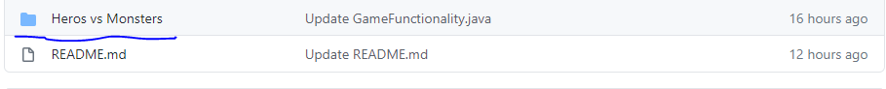

**Step 2**: Open the underlying folder and copy all the files in that folder. Save the folder on your computer in your desired location.

Example: I saved the files in my Documents folder in the file explorer tab. Please see below

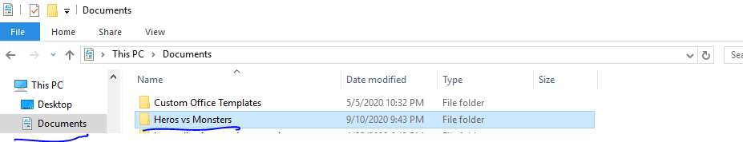

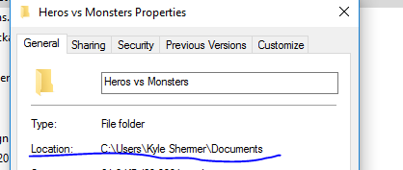

**Step 3**: Open your command prompt. Perform the command windows key + R and type in **cmd** and hit enter.

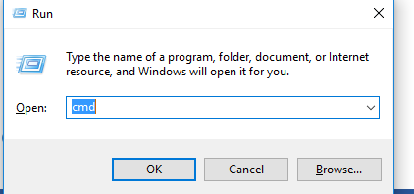

You should now see the command prompt as below:

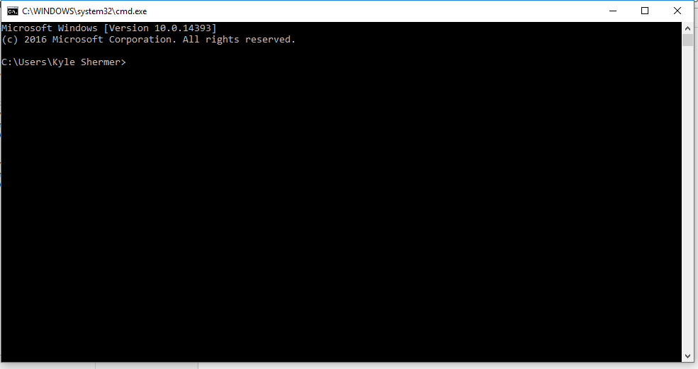

Step 4: Navigate on your computer to where you saved the folder Heros vs Monsters in the command prompt.

The below commands will guide you on navigating the command prompt to the desired location of where you saved the file

In the example below: I saved the file in my Documents tab.

C:\Users\Kyle Shermer\Documents\Heros vs Monsters

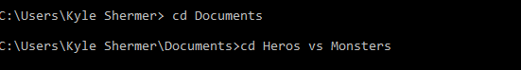

Step 5: Run the main class which will start the program:

**Command: java Driver**

You should now see the below:

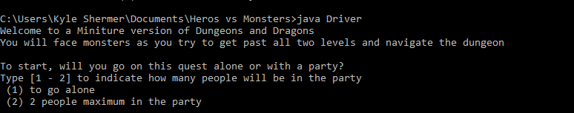

If you see this message below, that means you would have to add the JDK to your PATH environment variable.

“**javac’ is not recognized as an internal or external command, operable program or batch file**“.

**Adding the JDK to your PATH Environment**

Step 1: If you don’t have JDK installed you can go to the below site to download the JDK on your computer.

<https://www.oracle.com/java/technologies/javase-downloads.html>

Step 2: Once you have the JDK installed on your computer, locate where it was installed.

In my case, I opened up my File Explorer and my JDK is installed in the path below which you should see:

**C:\Program Files\Java\jdk1.8.0_251\bin**

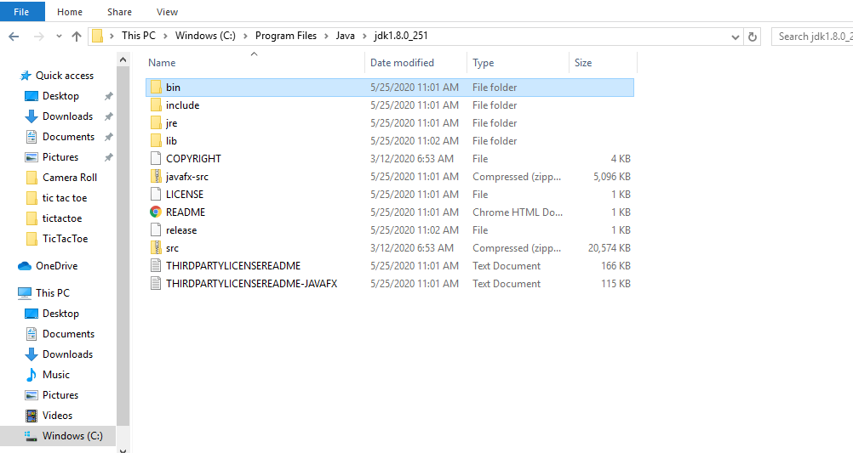

Step 3: Go to your control Panel and click on System and Security

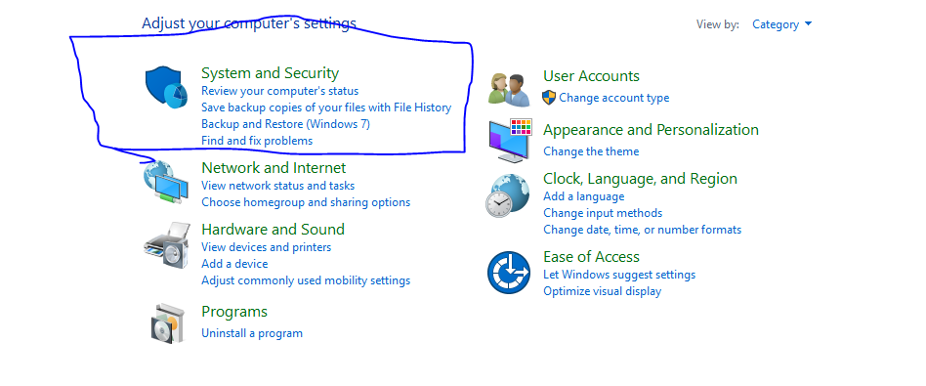

Step 4: Click System

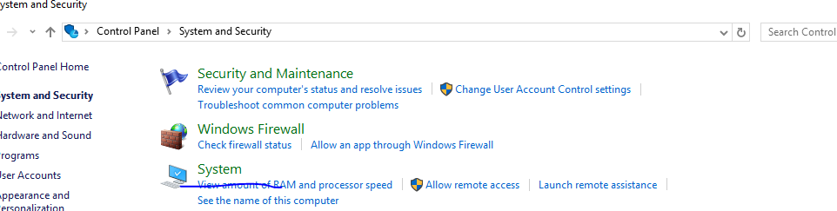

Step 5: Click Advanced system settings

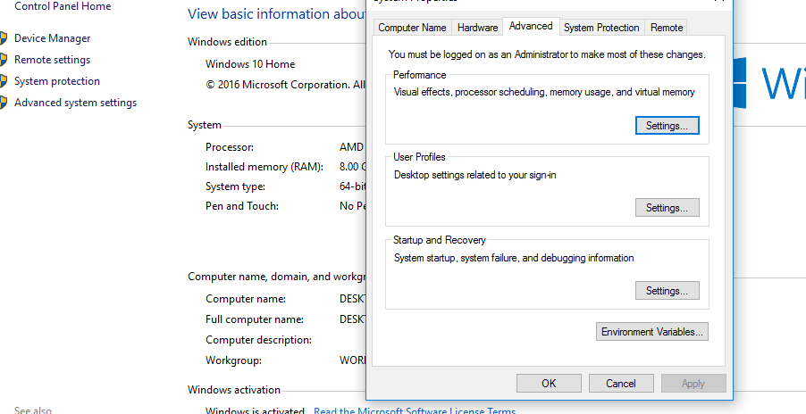

Step 6: Click Environment Variables and you should see a box named System Variables. Find the variable that says Path and click Edit

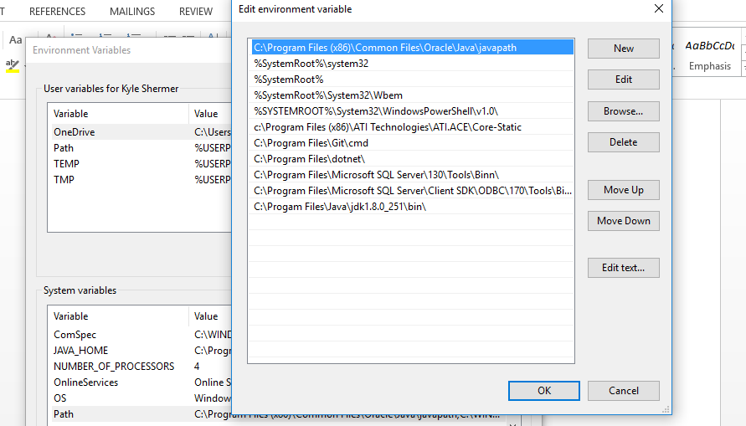

Step 7: Click New and copy the path where your JDK is installed on your computer. Hit okay.

In my case I would put as listed in the blue underline as below:

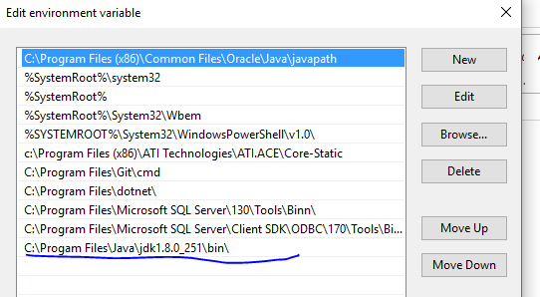

Step 8:

Hit Okay once are finished

Step 9: Repeat Step 5 in the Command Prompt

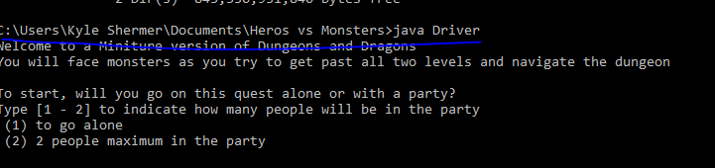

Step 10: Enjoy the game!